

My cousin, Deep who recently graduated from MAKAUT told me how difficult it is for a new graduate to land a job through LinkedIn. He had been trying for over 6 months, getting shortlisted for a few roles as well, but somehow unable to convert the interview. On further conversation with some of his peers , I found out that most of them were under-confident and did not have requisite soft skill, something that our colleges and universities do not train us for but companies look for. Also the curriculum is old and does not take into consideration the industry needs and new emerging domains. I was shocked to hear that some candidates are even frustrated with the process and leaving LinkedIn, often settling for jobs they aren’t passionate for.

On realising the issue, I took it up with the LinkedIn India team to brainstorm on how to solve this problem to make LinkedIn more meaningful to new graduates and our talented team of engineers, designers, analyst and researchers came out with an exciting product " **LinkedIn Freshers** " that would upskill the new graduates and train and guide them with interview preparation and choosing the right career track. The range of services that we will provide include AI based mock interview, courses based on career aspiration in LinkedIn Learning, expert mentorship from industry and academics , AI based resume builder , Industry connects , curated motivational, inspirational and interview experience videos and many more.

As of today, our feature launch has been going pretty strong as the data shows below

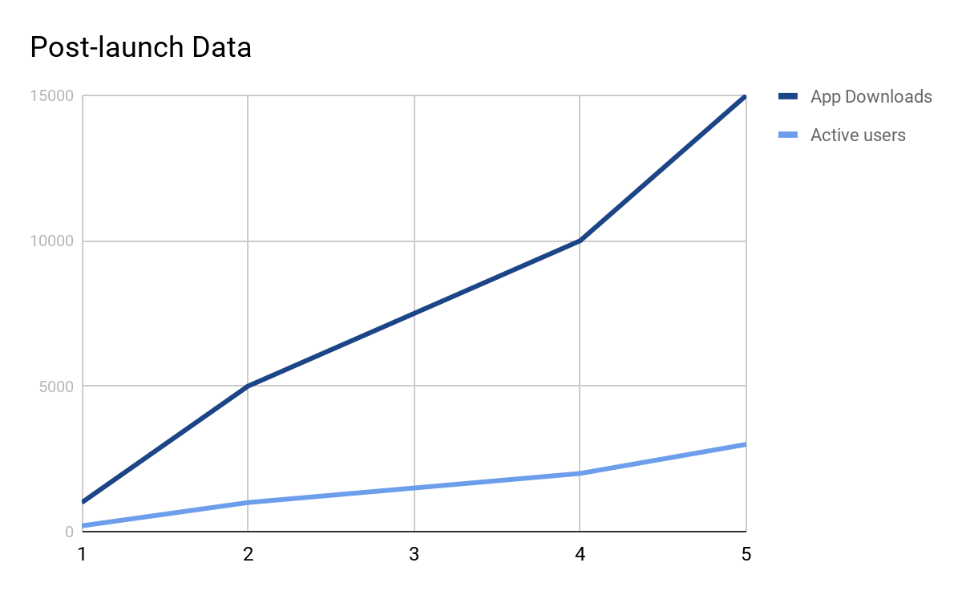

We are going to add more features based on our customer feedback and we are looking to launch internationally. This launch would not have been possible without the hard work of all the members of our team. Kudos to everyone.

Debdeep Bandyopadhyay,

Product Manager, LinkedIn Freshers